JS Execution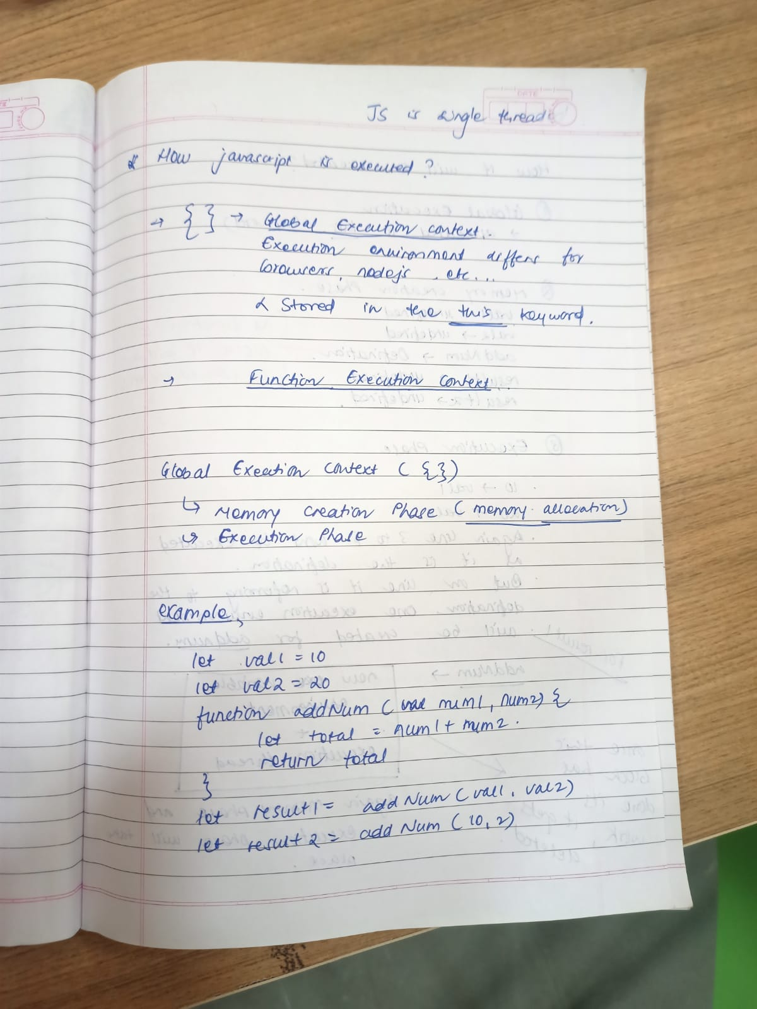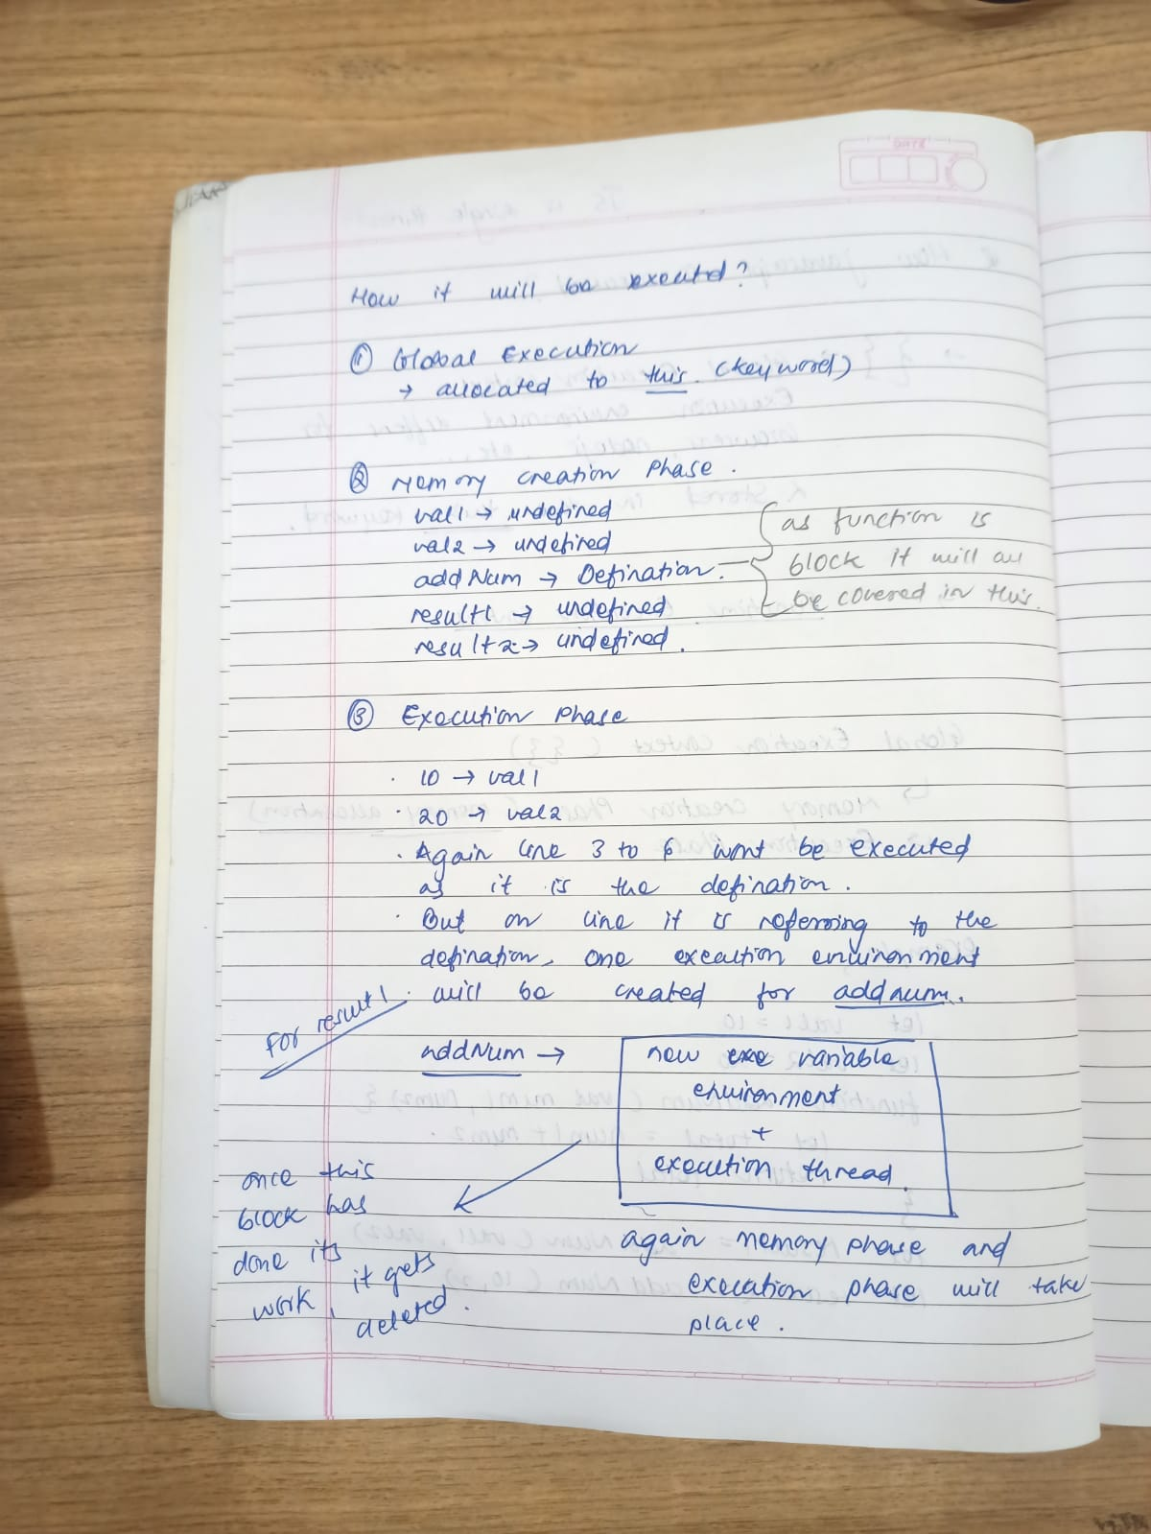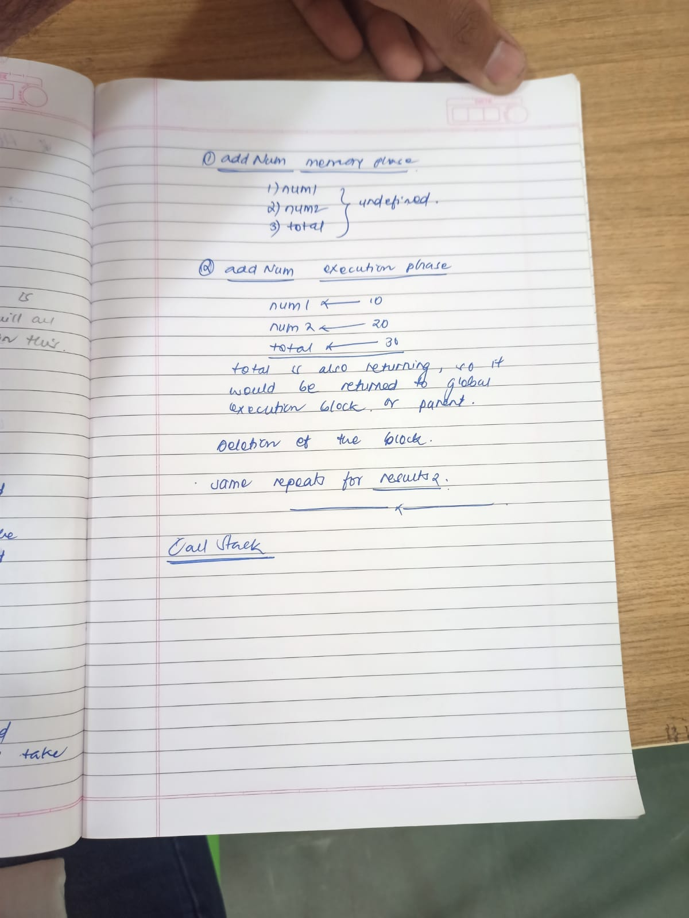

Call Stack

A **call stack** is a mechanism for an interpreter (like the JavaScript interpreter in a web browser) to keep track of its place in a script that calls multiple [functions](https://developer.mozilla.org/en-US/docs/Glossary/Function) — what function is currently being run and what functions are called from within that function, etc.